Experiment:20 Date:18/08/2027

STUDENT-TEACHER-SUBJECT-CODE

Aim:
To write a Prolog program to represent student, teacher, subject, and subject-code information using a database.

Algorithm:
- Start the program.
- Define facts for students and teachers.
- Define facts for subjects and their codes.
- Define the relationship between students and subjects.
- Query and display the required information.

Program:
student(aseem, cse).
student(arun, cse).
student(priya, ece).
teacher(ravi, cse).
teacher(meena, mathematics).
teacher(kumar, physics).
subject(ai, ai101).
subject(database, db102).
subject(network, cn103).
studies(aseem, ai).
studies(arun, database).
studies(priya, network).

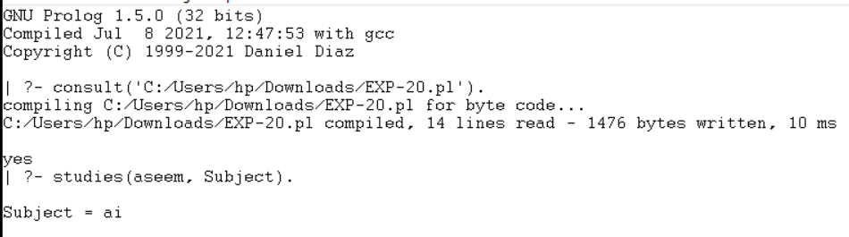
OUTPUT:

RESULTS:
Thus, the Prolog program was successfully executed to implement the student-teacher-subject-code database.

